Junior Philharmonic Society of New Orleans
2025-2026 Executive Board
President: Elyse Ptak
Treasurer: Lisette Bayle
Secretary: Mark-Anthony Thomas

Board Members

Lisette Bayle Ava Coffin. Peter Collins
Joel Dyson Emily Fransen Peggy Fransen
Gayle G. Greiner Margarita Harvey Nikki Hefko
Joni Jensen Rachel Jordon Bonnie Knowles
Chase Ludeau Katalin Lukacs Ava Rosenberg Nowalsky
Sheila Schwartzmann Mark-Anthony Thomas

2025 Donors

Lisette Bayle Louise Bush Dr. and Mrs. Alan Carr
Kelly Conatser Aimee Dodds Lillian Eyrich Peggy Fransen
Kim L Harvey Margarita Harvey Lauren Horn Erin Jensen
Joan Jensen Bonnie Knowles Jill Laroussini Katalin Lukacs
Ava Rosenberg Nowalsky Elyse Ptak Sheila Schwartzmann
Karen Smith Richard Snow Kristin White

Since 1948, our members have worked to provide Concerts and Awards that showcase talented young musicians, vocalists,
and dancers in our community. Please help us continue these efforts. Consider a donation on Give Nola Day May 5th givenola.org. Every Donation Counts!

https://www.jrphilnola.org

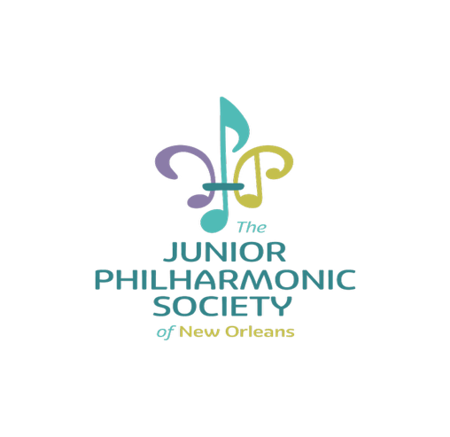
The
Junior Philharmonic Society
of New Orleans

proudly presents the
292nd
Performance
of
Young Artists

Sunday, April 19, 2026

2:00 pm Dixon Hall
Tulane University

Announcer- Lisette Bayle

Kitri Act I, Don Quixote ........................................ Minkus/Petipa
Hannah Voelkel, Dance

Kitri Act III, Don Quixote ..................................... Minkus/Petipa
Tabitha Morgan, Dance

La Esmeralda Entrance ............................................Pugni/Petipa
Lillian Williams, Dance

Gavotte from Flames of Paris..........................Asafyev/Ratmansky
Sarah Voelkel, Dance

Sonata in F Major .................................................... Telemann
Sicilienne ..................................................................... Fauré
Julia Vu, Flute

Sonata Hob XVI 4, Mvt.1 .............................................. Haydn
Op. 25, No. 2 .............................................................. Chopin
Elena Chen, Piano

Barcarolle ................................................................... Gillock
Mazurka in g minor ......................................................Chopin
Viola Prilmeier, Piano

Autumn Sketch ........................................................... Gillock
Valse Lente, Op 33 ................................................. Merikanto
Penny Shin, Piano

Mazurka in f minor ..................................................... Lyadov
Valse d’Automne .......................................................Tsitsaros
Jasmine Henry, Piano

Piano sonata Hob XVI 8 Mvt.1 ...................................... Haydn
Voiliers dans le vent .......................................... Jennifer Lynn
Alyvia Xie, Piano

Sonata in B-flat L.11, Mvt.1 .......................................... Haydn
Op75, no. 5 .............................................................. Sibelius
Bryce Davis, Piano

Duet, Op. 19, No.3 in D Major.................. Jean-Baptiste Breval
Liora Kaplan, Violin and Viola Prilmeier, Cello

Spring Comes to the Xiang River ...................................... Ning
Mason Wu, Guzheng

Gigue from Sonata in d minor, Op.2, No.7 ................... Veracini Praeludium and Allegro ............................................. Kreisler
Gaon Kim, Violin
Eric Sangsin Yu, Accompanist

Concertino in E-flat Op. 26 ...........................................von Weber
Meredith Bates, Clarinet

Diamond Fairy from Sleeping Beauty Act III .........Tchaikovsky/Petipa
Marlei McCloskey, Dance

Cupid Var. from Don Quixote.....................................Minkus/Petipa
Clare Carbajal, Dance

Gamzatti’s Var. from La Bayadère............................. Minkus/Petipa
Sarah Howard, Dance

Male Var. from Flames of Paris ............................ Asafyev/Vainonen
Gavin Howell, Dance

Neapolitan Dance from Swan Lake ........Tchikovsky/Petipa-Pettigrew
Cecilia Murray, Tabitha Morgan, Hannah Voelkel,
Sarah Voelkel, Emma Roebuck, Tabitha Owens,
Loreana Hunt, Genevieve Richoud, Allison Booth,
Lillian Williams - Dance Ensemble

............................................................................................................

Thank you!
To the Newcomb Department of Music, Tulane University, Kappa Kappa Psi, and Michael Batt.



